Janette Smith
Wedding Celebrant – renewal of vows – unity ceremonies

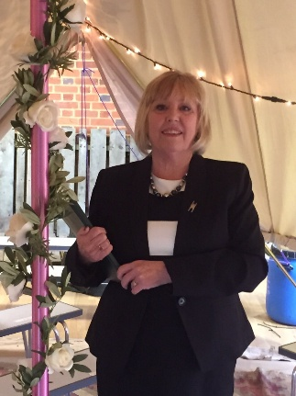

I am an experienced wedding celebrant who just loves her job! A Humanist wedding ceremony is totally unique and personal to you and I very much enjoy getting together with a couple and planning their ceremony with them and I’m happy to make suggestions and incorporate any ideas that you have for your own ceremony for readings, vows and symbolic acts. I’ve plenty of ideas of how to include important guests, children or adults, in your ceremony as well if that’s what you want. My main aim in any ceremony is to provide the “Special Day” that you want and what could be better than a personalised approach to planning it?
I have conducted weddings in a variety of locations from Stately Homes, back gardens, woods, fields, hotels, pubs, village halls and I’ve even done one for a TV pgogramme – CBBC “Marrying Mum and Dad” and I can honestly say, I’ve loved each and every one of them.
On a personal note, I have been married for 42 years and have two children so I’ve plenty of experience of being the mother of the bride and the groom’s mother as well and I’m more than aware of all kinds of sensitivities of organising a wedding ceremony. It was after a 35 year career in teaching that I became a celebrant and have not looked back since.
Please do contact me if you’d care to arrange a meeting or just ask a question:
I can be reached on 07970 119876 or via email at smithjanette60@yahoo.com

